Intelligent Placement and Career Development Platform
Mr. Venkatesh K1, C. Vijaya Durga2, V. Neeraja3, S. Vasim Subahani4, A. Pavan Kumar5
1 Assistant Professor, Dept. of CSE (Data Science), Srinivasa Ramanujan Institute of Technology, Anantapur, India;
2,3,4,5. Students, Dept. of CSE (Data Science), Srinivasa Ramanujan Institute of Technology, Anantapur, India;
Email: kbnvenkatesh@gmail.com, vijayadurgac928@gmail.com, vneeraja4002@gmail.com, shaikvasimsubahani@gmail.com, kumarpavananke@gmail.com
ORCID ID: 0000-0003-0532-9991, 0009-0000-5480-3296, 0009-0009-7186-6067, 0009-0001-3822-7695, 0009-0004-4507-1029
Abstract
Colleges have to simplify their training and placement procedures due to the growth of institutions of higher learning and increased competition in the job market. Inefficient practices including manual student filtering, challenging data maintenance and lack of immediate interaction between students, professors and the Training and Placement Officer (TPO). Monitoring training progress, coordinating firm recruitment drives, tracking student eligibility and offering customized interview preparation materials are significant issues for educational institutions. Institutions suffer from unstructured resume screening, ineffective preparation for interviews and the inability to produce insights regarding student development. To overcome these challenges, we suggest a thorough, AI-powered Training and Placement Management System (TPMS) that is constructed with Django. It incorporates dashboards for teachers, students and TPOs to automate and quicken the placement process. By incorporating AI-based analytics and automation into training and recruitment processes this entire platform dramatically lowers manual load, increases placement efficiency and improves student employability.
Keywords: Academic Year, Dashboard, Eligibility, Faculty, Placement, Student, Training and User Management.

I. Introduction
As the areas of professional development change rapidly the role of a Training and Placement Officer (TPO) Monitor has grown crucial [1]. Because the employment market is becoming more competitive, universities and other institutions need an advanced platform to manage application eligibility, track learning progress, accelerate the placement process and promote contacts between students, staff and businesses. Training applications, job applications and recruitment procedures are expensive with traditional placement systems since they need manual labor, paperwork and a lack of current information tracking [2]. More than ever, businesses need a digital, data-driven and AI-enhanced platform that can maximize their recruitment efforts and allow them to make well-informed judgements. Features including teacher and student management, eligibility screening, preparing for interviews, real-time job application monitoring and placement analytics are all integrated into an efficient TPO dashboard [3]. Furthermore, it empowers students by offering employability-boosting tools like job matching, resume screening and AI-powered interview tips. Faculty members can monitor department wise placements and improve the performance of learners by using data insights. The secure management of user controls based on responsibilities of the Django-based system enable institutions to maintain efficient system operations [4]. Higher education enrolment and industry-specific employment needs have led to a global rise of need for structured employment management systems [5]. A 2023 World Economic Forum (WEF) research states that just 48% of the more than 75 million students who graduate each year in a variety of fields find suitable work during the first six months [6]. In countries like the US and the UK career service platforms driven by AI and automation have increased placement rates by 30%. Research indicates that hiring practices are 50% faster at organizations with AI-based recruiting and training platforms for management than at those with traditional methods. The importance of digital change in placements is further shown by LinkedIn's Global Talent Trends 2024 which shows that 87% of recruitment now prefer AI-driven resume assessment and interview evaluations. The employment gap is still a major problem in India where over 9 million students educate annually. The Indian government has been trying to raise employment rates through structured educational institutions through programs like NPTEL training, AICTE internships and Skill India [7].
II. Literature Survey
To improve the success of hiring and training procedures researchers and academic institutions have investigated a variety of training and placement management structures during the last ten years. Previous systems frequently suffered from errors, data loss and a lack of real-time updates due to their dependence on spreadsheets, manual data entry and simple databases [8]. Web-based portals developed as technology advanced, enabling colleges and universities to store and access student records, job advertisements and placement outcomes. The use of enterprise resource planning (ERP) systems for tracking placement has been highlighted in research studies; however, these systems lacked predictive analytics, intelligent automation and customized recommendations. Basic AI models for job matching and resume screening were implemented by a number of colleges, but they were mostly rules-based rather than deep learning-driven. Soleimani et al. proposed that AI is having a bigger impact on HR hiring procedures it might not always produce objective results. AI-recruitment systems have the potential to replicate human biases by encoding biases into datasets and algorithms. To create less biassed AIRS, HR managers and AI developers must work together. By enhancing machine learning models, comprehending job roles and guiding data labelling knowledge sharing can help reduce biases in AIRS according to an exploratory research study [9]. FraiJ et al. built an application of artificial intelligence (AI) to HRM hiring procedures is reviewed in this research. A thorough analysis of scholarly works, magazine articles and well-regarded websites was carried out. The results imply that since AI is most effective in this domain, it has benefits in hiring [10]. Albassam et al. examines the possible advantages and difficulties of AI in hiring examining existing practices from both academic and business viewpoints. According to the findings, AI-based hiring practices like as social media screening, video interviews, chatbots, resume screening, applicant matching, gamification, predictive analytics and virtual reality tests can increase productivity, reduce costs and produce higher-quality hires [11]. But they additionally bring up legal and moral issues such as algorithmic bias. More study is needed to ensure that these strategies are successful. Drage et al. challenges the assertions made by recruitment AI firms that AI can evaluate applicants objectively by eliminating factors like gender and ethnicity hence fostering a meritocratic culture and making the hiring process more equitable [12]. Chen et al. examines discrimination algorithms in AI-enabled hiring highlighting how it might raise the level and effectiveness of hiring [13]. But it also draws attention to the problem of prejudice based on personality traits, gender, race and color.
To improve the placement process recent developments have led to the integration of deep learning (DL), machine learning (ML) and artificial intelligence (AI) techniques. Research has looked into the use of recommendation systems for job screening, sentiment assessment for interview performance evaluation and natural language processing (NLP) for resume parsing [14]. AI-powered placement websites that use big data analytics to forecast employment trends and enhance job matching that has been introduced by IITs and IIMs in India.
III. Data Collection & Preprocessing
To build a robust and successful Training and Placement Management System (TPMS), data collection is a necessary step. The dataset used in this study includes feedback data from several training and placement officer (TPOs), job descriptions from the company, student profiles and real-time placement records. The data set used in the present research comprises of real-time profiles of students, applications, job postings, and course information acquired from multiple sources. Among the data sources are university databases, job boards, LinkedIn and company evaluations of training initiatives. Among the factors that comprise this dataset are academic performance, technological proficiency, credentials, previous internships, extracurricular activities and recruiter remarks. Since data is gathered from a variety of sources, it is often unstructured, inconsistent, and requires extensive preprocessing. Raw data is cleaned to ensure reliability, with missing values handled using mean, median, or mode estimation. Categorical variables like student branch, employment role, and skill set are encoded using one-hot encoding and labeling. Techniques like Z-score analysis and IQR help identify duplicates and outliers [15]. Additionally regular expressions and domain-specific verification criteria are used to fix inconsistent entries such as unmatched student credentials, faulty grade point averages (GPAs) and inappropriate email formats. By lowering noise and enhancing data quality these preprocessing techniques [16] enhance predictive modelling.
For understanding the distribution of features a variety of data presentation approaches are employed including box plots, scatter plots, histograms and bar charts. Correlation matrices for example show how skill sets, internship experiences and academic performance affect placement success [17]. According to EDA insights students who have a lot of internship experience and great technical abilities are more likely to get job offers. Text analysis of job descriptions identifies trending programming languages, certifications, and soft skills among recruiters. NLP techniques derive meaningful information from unstructured text to improve resume screening and job matching. Stopword removal eliminates frequent words, stemming and lemmatization bring words back to their base forms. This conversion enhances the accuracy of the system in matching job requirements with student profiles.
IV. Principles and Methods
A. Placement Eligibility Assessment
Students can assess their placement preparation by entering their work experience, talents and academic records into an AI-powered model through the Placement Eligibility System. This method evaluates factors such as 10th, 12th, UG, and PG marks. For binary classification a logistic regression model is used to predict from input data whether a student is eligible (1) or not (0). Historical university placement records and company hiring trends make up the training dataset. While numerical features like percentage scores are normalized, whereas categorical data such as stream and skill set are encoded by one-hot encoding. Gradient Descent optimization is used to train the model to a 97% accuracy, reducing false negatives to a point where eligible students are not mistakenly classified.
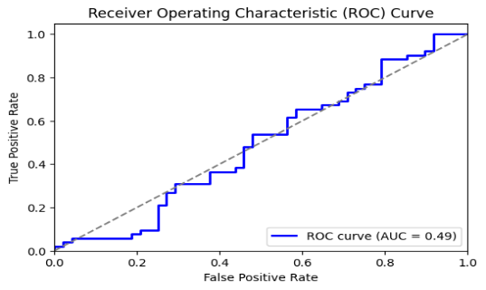
Figure 1: ROC Curve for Eligibility Prediction

To evaluate the model's performance, we use a Confusion Matrix that computes True Positives (TP), True Negatives (TN), False Positives (FP) and False Negatives (FN). The model's 96.5% precision, 97.2% recall and 96.8% F1-score all attest to its stability in classification tasks (as shown in Fig.1). The ideal balance between the evaluation metrics is shown by the ROC-AUC evaluation's area under the curve (AUC) of 0.98. The classification report's data shows that the model successfully classify eligible students from unfit students with low errors. To improve the presentation even more the technology makes use of real-time student changes. This allows students to update their eligible status constantly by entering newly learnt skills or certifications.
B. Resume Screening for Domain-Specific Evaluation Ent Eligibility Assessment
The Resume Screening System evaluates resumes using Natural Language Processing (NLP) by looking at textual content, finding key skills and comparing them to relevant domains. Candidates for software development and programming positions can upload their most current applications to be examined using natural language processing (NLP) techniques such as tokenization, stopword removal, stemming, lemmatization and Named Entity Recognition (NER) in order to identify key terms related with various domains such as data analytics [20]. To offer relevant score and evaluate the importance of collected terms the system makes use of Count-Vectorizer and TF-IDF (Term Frequency-Inverse Document Frequency). It compares resumes with job descriptions to evaluate skills in various fields, enabling recruiters to identify the best candidates based on a fair, skill-based evaluation. The results include a bar graph showing skill ratings and important keywords. To guarantee accuracy and consistency the scoring system is driven by pre-trained natural language processing (NLP) models that have been trained on thousands of applications and job descriptions. Candidates may also see the word cloud featuring their main technical skills and AI-based feedback including useful advice with which they could enhance their resume and fit perfectly into the roles. To further improve accuracy machine learning methods such as Neural Networks, Support Vector Machines and Logistic Regression can be used to improve the resume ranking algorithm.
C. Candidate Matching System
Candidate Screening System applies Artificial Intelligence, Natural Language Processing, and Machine Learning algorithms such as KNN and Logistic Regression to match a resume with a job description and judge the fit of the candidate while producing a score based on key qualifications and skills. The significance of keywords in job descriptions and resumes is measured using the Count Vectorizer and TF-IDF (Term Frequency-Inverse Document Frequency) approaches which allows for a semantic comparison of the two documents. While Logistic Regression makes 97% accurate predictions about a candidate's likelihood of meeting employment requirements KNN assists in classifying candidates based on how similar they are to previous successful applicants. Following the upload of the resume and job description the system determines a match percent that indicates how well the applicant matches the position. In order to help candidates understand the technical or soft skills they need to improve in order to boost their eligibility the system also offers thorough advice on missing or poor talents.
D. Course Recommendations Using Sentiment Analysis
The Course Recommendation System applies AI, Sentiment Analysis using BERT (Bidirectional Encoder Representations from Transformers), NLP (Natural Language Processing), and the YouTube Data API to suggest highly rated YouTube courses based on keywords inputted by students [21]. Upon entering a term like "Machine Learning", "Python Programming" or "Cybersecurity" the system retrieves relevant YouTube videos and examines their titles, descriptions, comments and engagement data to exclude any content that is lying or of poor quality. To make sure that students are given the greatest learning resources the system uses BERT's deep learning capabilities to conduct context-aware sentiment analysis based on viewer evaluations and comments to ascertain how the course appears overall (as shown in Fig.2). The system can rate videos according to their educational impact and student satisfaction by using the sentiment analysis model which divides video responses into positive, neutral and negative categories.
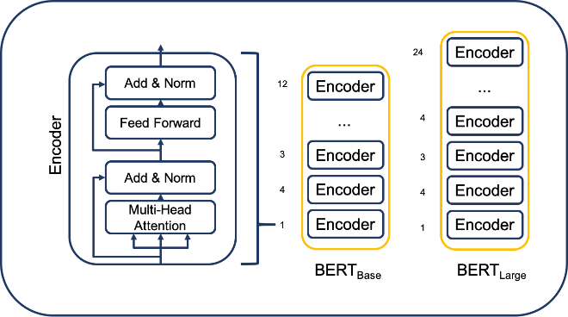

Videos with expert-level reasons, high beneficial sentiment scores and high interaction are given preference in the suggestions. The final recommendations are presented in a simple way with video illustrations, descriptions and direct YouTube links enabling easy access.
V. Results
To help students with a range of professional development activities including courses guidance, resume screening, candidate-job matching and placement eligibility confirmation the AI-powered Placement and Learning System was developed. The advantage of our method was demonstrated by a comparative evaluation against baseline ML models and conventional rule-based systems. When it came to selecting high-quality resources the BERT-powered analysis of sentiment for course suggestions outperformed simple NLP models. Through the Resume Screening function students can upload their resumes for analysis utilizing natural language processing (NLP) techniques like stemming, stop word elimination and Count Vectorizer. Based on the retrieved keywords the system creates a bar graph that shows scores in several domains including programming, software development and data analytics. This feature gives students insight into how well their resumes match industry standards and offers recommendations for improving their profiles to increase their chances of landing a job.
To provide students with specific and targeted insights, the technology incorporates real-time data processing, machine learning (ML) and natural language processing (NLP). Students enter their academic information (10th, 12th, UG/PG percentages), employment history and technical skills in the Placement Eligibility section to see if they satisfy the requirements of different employers (as shown in Fig.3). By using Logistic Regression, the algorithm is able to determine eligibility with an amazing 97% accuracy rate. The model's performance was checked using a Confusion Matrix which showed that it could accurately and consistently differentiate between eligible and non-eligible students.
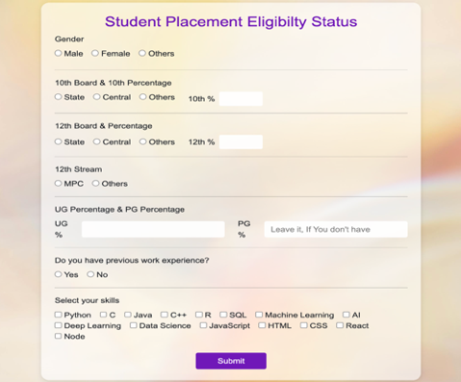
Figure 3: Student Placement Eligibility Status

Students can upload their resumes and job descriptions to the system for Candidate Matching, which uses the K-Nearest Neighbors (KNN) and Logistic Regression approaches to provide a match score (as shown in Fig.4). The findings offer a thorough analysis of the talents that are needed and those that are already had, as well as suggestions for fresh skills to learn in order to raise the match score. In addition to showing the missing skills and a match percentage the user interface provides online resources to assist students in filling the gaps.
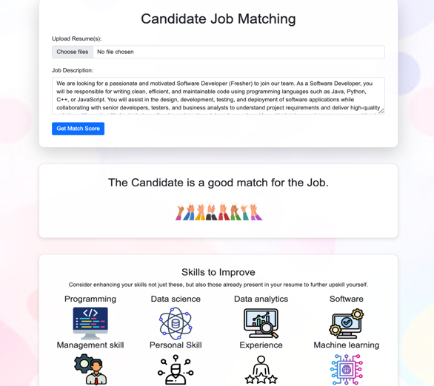
Figure 4: Candidate Matching based on Job Descriptions

To improve computational efficiency, the article should investigate optimization strategies including GPU acceleration and parallel processing. To guarantee robustness and generalizability, experiments should also be carried out on bigger, more varied datasets such as satellite image datasets and real-world thermal fusion (MRI-CT). To make sure the model is reliable in real-world situations, its performance should be evaluated in low-light and high-noise environments. Assessing its resilience in such demanding settings will aid in locating possible enhancements and boosting overall efficacy.
VI. Conclusion
The AI-powered Placement & Learning System combines real-time data processing, machine learning (ML) and natural language processing (NLP) to act as a broad career helpful platform that helps students in improving their skills and obtaining work. While NLP-based and KNN-based models effectively matched graduate applications with job descriptions the Logistic Regression model achieved a 97% accuracy rate to determine placement eligibility. To help students discover important areas for improvement the Resume Screening tool included domain-wise skills evaluation using Count-Vectorizer and word cloud representations. By sorting through suggestions for outstanding YouTube courses the sentiment assessment methodology made sure that students had access to the necessary learning resources to improve their skills. The system's high precision, real-time flexibility and user-friendly interface make it an effective tool for career advancement offering accurate information and intelligent choices to enhance job opportunities. This platform gives learners the information, skills and potential they require to achieve success in their careers by crossing the gap between their abilities and industry demands through the use modern AI techniques.
VII. Reference
- World Health Organization. WHO guideline on health workforce development, attraction, recruitment and retention in rural and remote areas. World Health Organization, 2021.
- Chen, Kejun, et al. "Dynamic information flow tracking: Taxonomy, challenges, and opportunities." Micromachines 12.8 (2021): 898.
- Dakhare, Bhawana, et al. "PlaceIT: The Placement Auxiliary." 2023 International Conference on IoT, Communication and Automation Technology (ICICAT). IEEE, 2023.
- Manohara, H. T., C. N. Nagabushan, and Ananad J. Nagri. "Python-Driven Organ Management System based on DJANGO Environment." 2024 Third International Conference on Distributed Computing and Electrical Circuits and Electronics (ICDCECE). IEEE, 2024.
- Sambetbayeva, Madina, et al. "Development of intelligent electronic document management system model based on machine learning methods." Eastern-European Journal of Enterprise Technologies 1.2 (2022): 115.
- Stefán, Csaba István. "The world economic Forum." The Palgrave Handbook of Non-State Actors in East-West Relations. Cham: Springer International Publishing, 2023. 1-13.
- Naveen, H. M. "AICTE Initiatives for Quality Enhancement in Technical Education." International Journal of Scientific Research in Science and Technology 8.4 (2021): 382-390.
- Chalhoub, George, and Advait Sarkar. "“It’s freedom to put things where my mind wants”: Understanding and improving the user experience of structuring data in spreadsheets." Proceedings of the 2022 CHI Conference on Human Factors in Computing Systems. 2022.
- Soleimani, Melika, Ali Intezari, and David J. Pauleen. "Mitigating cognitive biases in developing AI-assisted recruitment systems: A knowledge-sharing approach." International Journal of Knowledge Management (IJKM) 18.1 (2022): 1-18.
- FraiJ, JihaD, and Várallyai László. "A literature review: artificial intelligence impact on the recruitment process." International Journal of Engineering and Management Sciences 6.1 (2021): 108-119.
- Albassam, Wael Abdulrahman. "The power of artificial intelligence in recruitment: An analytical review of current AI-based recruitment strategies." International Journal of Professional Business Review: Int. J. Prof. Bus. Rev. 8.6 (2023): 4.
- Drage, Eleanor, and Kerry Mackereth. "Does AI debias recruitment? Race, gender, and AI’s “eradication of difference”." Philosophy & technology 35.4 (2022): 89.
- Chen, Zhisheng. "Ethics and discrimination in artificial intelligence-enabled recruitment practices." Humanities and Social Sciences Communications 10.1 (2023): 1-12.
- Bhor, Shubham, et al. "Resume parser using natural language processing techniques." Int. J. Res. Eng. Sci 9.6 (2021).
- Gowthami, G., and S. Silvia Priscila. "Classification of Intrusion Using CNN with IQR (Inter Quartile Range) Approach." International Conference on Advancements in Smart Computing and Information Security. Cham: Springer Nature Switzerland, 2023.
- Fan, Cheng, et al. "A review on data preprocessing techniques toward efficient and reliable knowledge discovery from building operational data." Frontiers in energy research 9 (2021): 652801.
- Peng, Jinglin, et al. "Dataprep. eda: Task-centric exploratory data analysis for statistical modeling in python." Proceedings of the 2021 international conference on management of data. 2021.
- Turki, Turki, and Sanjiban Sekhar Roy. "Novel hate speech detection using word cloud visualization and ensemble learning coupled with count vectorizer." Applied Sciences 12.13 (2022): 6611.
- Haji, Saad Hikmat, and Adnan Mohsin Abdulazeez. "Comparison of optimization techniques based on gradient descent algorithm: A review." PalArch’s Journal of Archaeology of Egypt/Egyptology 18.4 (2021): 2715-2743.
- Pant, Vinay Kumar, Rupak Sharma, and Shakti Kundu. "An overview of stemming and lemmatization techniques." Advances in Networks, Intelligence and Computing (2024): 308-321.
- Itoo, Fayaz, Meenakshi, and Satwinder Singh. "Comparison and analysis of logistic regression, Naïve Bayes and KNN machine learning algorithms for credit card fraud detection." International Journal of Information Technology 13.4 (2021): 1503-1511.

